Bulk and Retail Petroleum

Module 5

Sections 18 to 295 of the Weights and Measures Regulations

January 2021

Uncontrolled copy for training purposes only

Table of contents
Section 18 6
Form of Marking of Devices 6
Section 21 6
Marking of approved weighing machines, measuring machines and related equipment or accessories 6
Section 22 & 23 6
Marking Approved Weighing Machines, Measuring Machines and Related Equipment or Accessories 6
Section 25 & 26 - Marking Devices "Not for Use in Trade" 7
Section 27 7
Specifications Relating to Installation and Use 7
Section 28 (1) 7
Examination of Instruments 7
Section 29 and 29.1 – General 8
Examination of devices 8
Section 30 and 31 - Marking Devices 8
Section 32 - Sealing of Devices 9
Section 33 9
Accessibility and Assistance for Examining, Testing and Sealing Devices 9
Section 34 & 35 10
Device Maintenance and Adjustment 10
Section 38 10
Reporting Location of Devices Installed for Use in Trade 10
Section 39 10
Reporting Location of Devices Installed for Use in Trade 10
Section 40 11
Written Notice Subsequent to Repairing Device 11
Section 41 (1) 11
Report Subsequent to Altering, Adjusting or Repairing Device 11
Section 42 11
Reporting Removal of Marking or Tag or Breaking of Seals 11
Section 44 11
Limits of Error of Devices 11
Local Standards 12
Section 56 14
Calibration and Certification of Local Standards 14
Section 65 - Part V - Specifications Relating to Devices 14
Section 66 - Division I - Devices in General 14
Design, Composition and Construction 14
Section 67 - Division I - Devices in General 14
Performance 14
Section 68 - Division I - Devices in General 15
Installation and Use 15
Schedule II – Part II 15
Section 120 16
Interpretation 16
Section 129 - Division V - Weighing and Measuring Machines in General 16
Design, Composition and Construction 16
Section 130 16
Return to start position 16
Sections 138 & 139 - Division V - Weighing and Measuring Machines in General 17
Performance 17
Sections 140 to 149 - Division V - Weighing and Measuring Machines in General 18
Installation and Use 18
Environmental Protection 18
Customer Visibility 18
Sections 233 to 237 - Division X - Volumetric Liquid Measuring Machines in General 19
Design, Composition and Construction 19
Sections 243 to 249 - Division XI - Volumetric Liquid Meters 20
Design, Composition and Construction 20
Sections 252 to 260 - Division XI - Volumetric Liquid Meters 21
Design, Composition and Construction 21
Sections 261 to 267 - Division XI - Volumetric Liquid Meters 21
Performance 21
Section 270 - Division XI - Volumetric Liquid Meters 22
Sections 273 to 280 – Division XI – Volumetric Liquid Meters 23
Installation and Use 23
Sections 281 to 282 - Division XI - Volumetric Liquid Meters 24
Installation and Use 24
Sections 283 to 287 - Division XI - Volumetric Liquid Meters 25
Installation and Use 25
Sections 290 to 293 25
Section 294 26
Section 295 26
Insert a copy of Sections 18-295 of the Weights & Measures Regulations

Section 18

Form of Marking of Devices
GEN-39 Replacement information and information plates

Section 21

Marking of approved weighing machines, measuring machines and related equipment or accessories
Information to be marked on approved measuring machines before being sold, leased or otherwise disposed of:
- the name of the manufacturer or importer;
- the model number and serial number;
- the approval number;
- the range for which it was approved pursuant to section 3 of the Act; and
- any other information that is required by the Notice of Approval.
- the minimum and maximum flow rates, and
- if the meter is equipped with an automatic temperature compensator, the words “Volume corrected to 15°C” or “Volume corrigé à 15°C”, immediately adjacent to the registration of net quantity.

Section 22 & 23

Marking Approved Weighing Machines, Measuring Machines and Related Equipment or Accessories

Section 22
- A device referred to in subsection 28(2) which is approved but cannot be examined until it is installed, is to be marked:
- “Not for Use in Trade Until Examined”

Subsection 23(1)
- A device that is NOT approved, is to be marked:
- “Not Legal for Trade”

Subsection 23(2)
- A device described in paragraph 4(2)(a) is to be marked:
- “For Prepackaging Use Only”

Section 25 & 26 - Marking Devices "Not for Use in Trade"
- Section 25 explains that before a dealer sells or a person disposes of a device that is approved for use in trade, but will not be used for trade purposes, be marked “Not for Use In Trade”.

- Section 26 makes it a requirement for traders that own approved devices, but do not use them for trade transactions, to mark the devices “Not For Use In Trade”.

A few sections in the Act contain the expression "a trader who uses, or has in his possession for use, in trade".
- Section 36 of the Act states that where a trader has in his possession any device that is not marked to show that it is not for use in trade, he shall, in the absence of evidence to the contrary, be deemed to have that device in his possession for use in trade.

The trader is responsible for marking appropriately any device in his possession. If the device is not marked properly, the onus is on the trader to prove that the device is not used in trade.
In the performance of your duties (examiner or prosecution), an inspector considers all devices found in a place of business to be for use in trade unless they are marked otherwise pursuant to Section 23 or Section 26 of the Regulations.
These markings are the only indication that may be accepted as evidence that the device is not for use in trade.

Section 27

Specifications Relating to Installation and Use
- Section 27 grants the Minister authority to make specifications relating to installation and use of devices.

Section 28 (1)

Examination of Instruments
- Section 26(1)(c) of the Act makes it an offence for a dealer to sell or dispose of a device without having it examined as prescribed. This Section 28 of the regulations prescribes that the device either be examined or marked appropriately.

- Section 28(1) refers to the initial examinations

- In reference to Section 22, it states “Not for Use In Trade Until Examination”

- In reference to Section 25, it states “Not for Use in Trade.”

Section 29 and 29.1 – General

Examination of devices
- Subsection 29(1) establishes the examination period for devices used in trade or possessed for use in trade following their:
- initial examination; or
- most recent subsequent examination.

- Subsection 29(1) states that the shortest period set out in column III applies if the device falls under more than one item of Part I of Schedule I (i.e., 1, 2 or 5 years).

- Section 29.1 allows for granting a trader an extension of up to 1 year due to circumstances beyond their control and when no previous extension period has been granted. The Minister grants this extension if the conditions set out in section 29.1 have been met.

Section 30 and 31 - Marking Devices
- While Section 28 of the regulations requires devices to be either examined or marked, Section 29 requires an inspector who has determined that a device meets the requirements of the Weights and Measures Act and Regulations to mark the device or its container with:
- a steel die, or
- a sticker
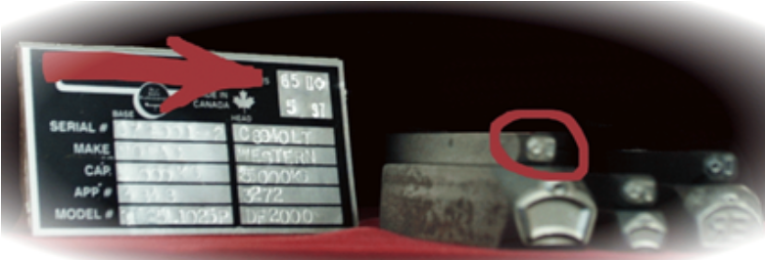

- Section 30.1 requires an inspector to place an examination sticker on the device in conjunction with the examination mark.

- Subsection 31(1) requires an inspector to place an examination sticker on a device when a device meets the requirements of the Act and Regulations in the case of an examination performed during the prescribed period or by the owner’s request. (Subsequent examinations).
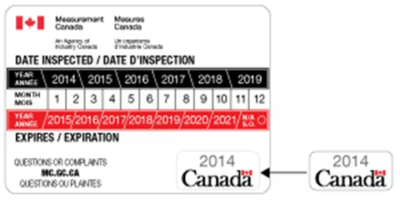
References to the Act:
section 15 of the Act provides the authority to examine devices

Section 32 - Sealing of Devices
Seals must be of the self-adhesive, self-locking or lead-and-wire type.

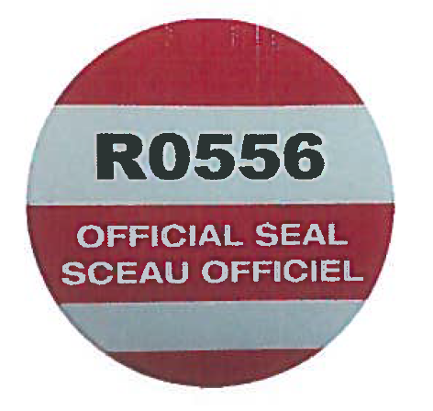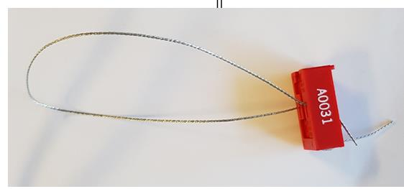

Section 33

Accessibility and Assistance for Examining, Testing and Sealing Devices
- Section 33 ensures that devices are installed in such a manner that an appropriate amount of standards may be brought by customary means to the installation so that the systems can be easily examined and sealed.
- The onus is left to the owner of the device should accessibility be a problem of the installation

Section 34 & 35

Device Maintenance and Adjustment
- Section 34 Device Maintenance:
- Measuring elements, the accuracy of which can be affected by product or debris, should be kept clean and free from obstruction.

- Section 35 requires any adjustments made to a device rectify only those conditions that they are designed to correct. For instance, if the results of a meter test revealed the measuring element to be replaced for non-repeatability errors, the adjuster should not calibrate to compensate.

- Section 35(1) compels anyone who makes repairs or alters a device where the alteration may affect its accuracy to calibrate that device as close to zero error as possible before returning it to service.

Section 38

Reporting Location of Devices Installed for Use in Trade
When a device fits in either of these categories:
- A volumetric liquid measuring machine (receiving/dispensing system)
- A device that requires to be properly installed on a base, foundation, etc., before use so that the performance of this device are not affected

The trader must report to MC information about the device and provide the address and details about where it is installed, as per 38(2). If the device is moved to another location and reinstalled, a new examination is not required, but the trader must report to MC as per 38(3). If a device is examined and a device examination certificate is delivered, it is considered sufficient information to fulfill requirements laid out in Section 38. There’s no need for another report.
Section 38 does not apply to:
- devices that are exempt under Section 4
- or those specific devices and trade transactions exempt by the Minister, under section 7

Section 39

Reporting Location of Devices Installed for Use in Trade
- Section 39(1) discusses vehicle mounted measuring machine for
- Receiving, or
- Dispensing

Trader must report as prescribed in section 39 (1) and (2).

- Under Section 39(2) when a trader decides to move the home location of their vehicle mounted measuring machine, the trader is expected to report its new location.

Section 40

Written Notice Subsequent to Repairing Device
While subsection 4(1) and section 7 outline exempt devices from approval and examination, paragraphs 29(a) and (b) and section 30 of the Act, make it an offence for anyone who repaired a device, as requested to do so by a trader, and allowed that device to leave his possession before they gave written notice to an inspector.
Section 40 details the information to be reported.
“Report of Repairs, Alterations and Adjustments”

Section 41 (1)

Report Subsequent to Altering, Adjusting or Repairing Device
- Section 41(1) requires repair companies or persons who make repairs on a device, whether or not they take possession of the device, to report the repairs, adjustments or alterations within 5 days as detailed.

Section 42

Reporting Removal of Marking or Tag or Breaking of Seals
- Section 30 of the Act makes it an offence for every person who removes any markings or tag or breaks any seal placed on a trade device unless that person completes a report with the information contained in Section 42(a) through (h).

Section 44

Limits of Error of Devices
- While Section 24(b) of the Act makes it an offence to use a device that does not measure within the limits of error, Section 44(a) authorizes the use of the appropriate table to establish in-service limits of error found in Part V of the Regulations.
- Paragraph 44(b) of the regulations states that the applicable limits of error referred to in paragraph 24(b) of the Act are the in-service limits of error in the applicable Specifications established pursuant to subsection 13(1).

Local Standards
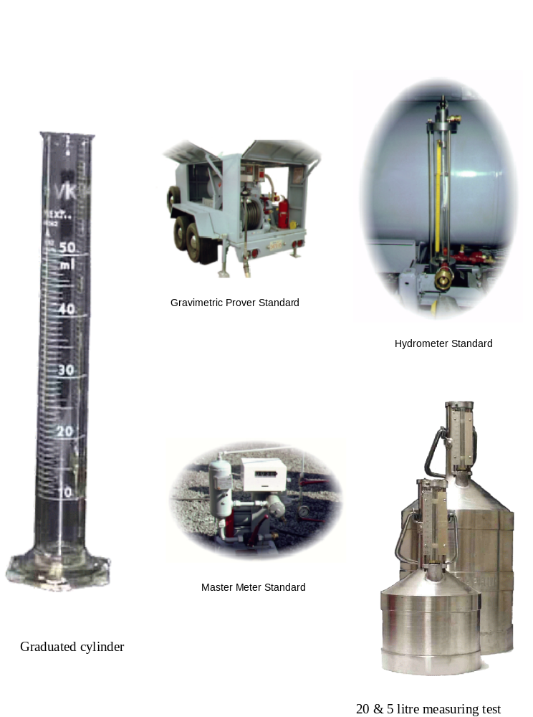
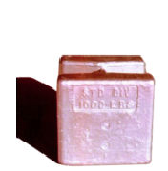  Nominal Weight Value of 500 kg | 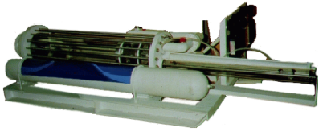
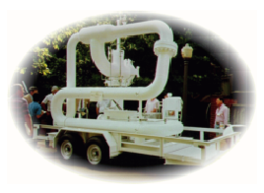 |  | 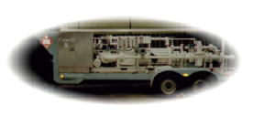
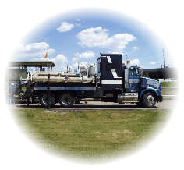  “Ball” type Pipe Prover |  | 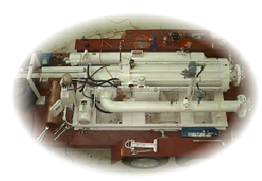  “Piston” type Pipe Prover

Section 56

Calibration and Certification of Local Standards
- Section 56 sets out the calibration frequency for the local standards listed:
- Weights
- Volumetric Static Measures
- Volumetric Measuring Machines
- Linear Static Measures
- tape measures
- yard and metre sticks

Section 65 - Part V - Specifications Relating to Devices
- Section 3 of the Act grants the Minister authority to approve devices. This Section 65(1) establishes specifications relating to the design, composition, construction, performance and installation before a device may be considered for approval.
- A Non-Automatic weighing device only weighs discrete loads statically while an Automatic weighing device can weigh loads either statically or dynamically but always follows a predetermined program of automatic process.
- Non Automatic Weighing Devices are exempt from this part of the regulations.

Section 66 - Division I - Devices in General

Design, Composition and Construction
- Section 66 requires the design and makeup of devices to be durable and rugged, able of maintaining its calibration throughout its life. Any possibility of fraud involving the design and makeup of the device should be eliminated at the device’s design stage.

Section 67 - Division I - Devices in General

Performance
- Devices should be designed to maintain their accuracy within the in-service limit of error for a reasonable amount of time as set out in the adjacent table.

- Section 67(2) authorizes linear interpolation when interpreting specific values falling between those listed in the tables relating to performance limits of error.

Section 68 - Division I - Devices in General

Installation and Use
- Section 68(1) not only suggests devices be installed, maintained and used in order to insure accurate measuring–it also suggests that all means that could lead to fraudulent use be eliminated. Though this section may be used as a catch-all from time to time it will definitely give inspectors support when correcting installation and use problems.

- In Section 68(2) the tables to Schedule II are identified. These tables list the limits of error for quantities of commodity measured in various units of mass, volume and length.

- 68(2) also requires devices used to measure commodities have the appropriate increment of registration for the commodity being measured.

Schedule II – Part II
Item | Column I – Stated Quantity | Column II Limits of Error
 | litres | % | millilitres
8 | more than 10 to no more than 15 | - | 150
9 | more than 15 to no more than 50 | 1 | -
10 | more than 50 to no more than 100 | - | 500
11 | more than 100 | 0.5 | -

- Section 69 requires devices to be installed as per the manufacturers’ installation instructions.
- If the manufacturer’s instructions contradict any part of these regulations or specifications then the Act, Regulations or Specifications are to be considered as correct. The Weights and Measures Legislation will take precedence.

- A device’s use can be prohibited through Section 70:
- In the last certificate examination.
- In the device notice of approval.

- When the use of a device is prohibited in some manner, a sign that is easily read by all parties involved must be posted stating the prohibition(s).
- Minimum deliveries
- Legal for gasoline only
- Maximum capacity

Section 120

Interpretation
- “machine” means a weighing machine or measuring machine for use in trade, other than one referred to in the Specifications Relating to Non-Automatic Weighing Devices (1998);
- “registration” includes both visual indication and recorded representation of quantity, unit price or monetary value.

Section 129 - Division V - Weighing and Measuring Machines in General

Design, Composition and Construction
- Section 129 discusses the printed information requirements for machines that provide printed records. These are:
- the quantity measured in the transaction or a start and finish print (so that the quantity can be calculated by subtraction)
- If the statement contains computed price, the unit price must be indicated as well as the unit of measurement.

Section 130

Return to start position
Before a delivery can be made a metering system must give an operator visual confirmation that the device has been properly returned to a start position. If equipped with a printer the printer must also indicate the start position.

Sections 138 & 139 - Division V - Weighing and Measuring Machines in General

Performance
- Section 138 discusses the repeatability requirements. The acceptance or in-service limits of error are found in Section 263.
- Section 139 discusses how the following must concur:
- Indicator and Printer
- Primary Indicator and Secondary Indicator
Digital Registrations
- Indications must be in exact agreement when graduations are the same and,
- Indications must be within 0.6 times the largest of those values of minimum increment of registration when graduations are not the same.

Example: Primary graduation = 0.01 L, printer graduation = 0.1 L.
These indications must agree within 0.6 x 0.1 L = 0.06 L.
If primary indication = 40.04 L, printer can be 40.1 L or 40.0 L

Mechanical Digital
- Indications must be within 0.6 times the largest of the values of minimum increment of registration whether the graduations are the same or not. This is effectively the same requirement as for digital registrations. If the graduations are the same, the indications must be the same because one graduation higher or lower would be more than 0.6 times the graduation.

Analog Registrations
- Indications must be within 0.25 times the largest of the values of minimum increment of registration whether the graduations are the same or not.

Example: Primary and secondary indicators both have 0.01L graduation.
These indications must agree within 0.25 x 0.01L = 0.0025L (1/4 of one graduation).
If primary indication = 40.04L, secondary can be from 40.0375L to 40.0425L
(analog registrations can be read between graduation marks).
Example: Primary graduation = 0.01L, secondary graduation = 0.1L.
These indications must agree within 0.25 x 0.1L = 0.025L.
If primary indication is 40.05L, secondary can be from 40.025 L to 40.075L.
Combined Digital and Analog Registrations
- Indications must be within 0.6 times the largest of the values of minimum increment of registration whether the graduations are the same or not.

Example: Primary analog graduation = 0.1L,
mechanical digital printer graduation = 1L. These indications must agree within 0.6 x 1L = 0.6L. If the primary indication = 40.4L, printer can be 40L or 41L.

Sections 140 to 149 - Division V - Weighing and Measuring Machines in General

Installation and Use
Registration of monetary value must agree with the quantity measured and its unit price. The registrations must be clearly marked so that there is no confusion between the quantity registrations and the monetary value.
Section 140 refers to limits of error for registration of monetary value as prescribed by the Regulations or Specifications. SVM 1-28 (to be reviewed later) prescribes the limit of error for registration of monetary values and states that computed total price shall agree to the nearest cent with the product of the unit price displayed and the quantity delivered.
Example:
Unit price $0.995 / Litre & quantity delivered (registered) is 20.004 Litres
0.995 x 20.004 = $19.90398 which rounded to the nearest cent is $19.90
($19.91 would be incorrect).

If the price computation was exactly 0.5 cents, then rounding to the nearest cent, either up or down, would be acceptable.

Section 141 discusses how installation of equipment and components should be connected to an electrical supply as specified by the manufacturer or as established by another specification:
- Specifications on Electric Registers and Ancillary Equipment Incorporated in Metering Assemblies Specifications (SVM-1)
- Specifications on Metering Assemblies Incorporating Electronic ATCs (i.e. Automatic Temperature Compensation) (SVM -2)

Environmental Protection
Section 142 discusses how Machines should be protected from environmental factors that might affect performance,

Customer Visibility
Section 143 of the Regulations requires that a weighing or measuring machine be located so that the indicator can be clearly read by any party to a transaction for which the machine is being used or, if owing to circumstances, that is not feasible, a secondary indicator must be provided to allow parties to read the indication.
Though the secondary indicator need not be approved, it must indicate the unit of measurement.
Section 144 requires devices to be installed so that an operator at the primary indicator has a clear view of the measuring element or delivery outlet.

Section 149 To ensure that all means of registration meet the requirements.
This section sets out to eliminate the possibility of incorrect printed information and requires a ticket appropriate to the printer, reducing human temptations and eliminating the possibility of information being printed in wrong, inappropriate places.

Sections 233 to 237 - Division X - Volumetric Liquid Measuring Machines in General

Design, Composition and Construction

Section 233 talks of the anti-drain valve.

Section 234 explains that capacity indicators are found in delivery tanks and should be designed to be sealed. All adjustments of a volumetric liquid meter must be designed to be sealable.

Section 235 states that component parts must be sealable when they might have an effect on the machine’s measuring accuracy.
- For example, milk meters are designed to facilitate complete disassembly including the measuring element for cleaning and sanitary processes.

Section 236 should be examined in the context of the Specifications on Metering Assemblies Incorporating Electronic ATCs (i.e. Automatic Temperature Compensation (SVM-2), which authorizes temperature correction to 15 /C.

Section 237 explains that a machine can be tested and calibrated with another liquid than the one intended for the machine as long as it has similar hydraulic proprieties or that it is used with a correction factor specified by the Minister. For example:
- For example, testing dispensers in the shop with mineral spirits or testing new meters intended for NH3 product using correction factors with mineral spirits.

Sections 243 to 249 - Division XI - Volumetric Liquid Meters

Design, Composition and Construction
It is a well-known fact that meters are less accurate when used at slower flow rates.
Section 243 requires meters to be operated above the rated minimum flow to ensure the meter is used in a more linear area of its meter curve.

Section 244 requires a filter/strainer to protect the meter’s measuring element.

Section 245 of the Weights and Measures Regulations requires an automatic air-vapour eliminator to be installed with all meters except slow-flow meters and slow-flow dispensers.
- Differential and back pressure valving will insure liquified products do not vaporize at the meter.
- In the case of bulk meters installed at loading racks for the delivery of refined petroleum products, an installation without an air eliminator may be considered to meet the intent of section 245 if it complies with specific conditions found in Bulletin V-21-E.
- A Slow Flow Meter is a meter with a minimum rating of 2 litres/hour, intended for use on an approved pipeline system for the distribution of fuel oil, stove oil, or kerosene to furnaces or other heating equipment, as well as for use on a motor vehicle to measure fuel for tax rebate purposes, or some other service where it is permanently installed to a point of consumption.
- A Slow Flow Dispenser is an assembly of a meter, which may be a self-measuring pump and accessories, which may or may not be housed in a cabinet, generally intended for motor vehicle lubricants or antifreeze and for individual deliveries of a litre or more.

Section 249 of the Regulations requires that the means of registration on a meter shall be capable of advancement only by the liquid passing through the meter.
- Registrations, advanced via the Measuring element, should not progress by the moving/pumping of air through them.

A register which, once installed in its normal operating condition, is capable of advancement only by the liquid passing through the meter shall be deemed to meet the requirements of subsection 249(1) of the Regulations.
- Subsection 2 requires meter designs to be such that they must reset to zero prior to any delivery.
Section 250 explains that any resettable register, totalizer or ticket printer on a meter designed to measure flow in both directions will advance (or reverse in the same direction as the flow.

Sections 252 to 260 - Division XI - Volumetric Liquid Meters

Design, Composition and Construction
Section 252 states that monetary and volume registrations must return to zero simultaneously.

Section 253 states that there can be no price changes while a computing register is in use. Some electronic registers have an optional "time out" feature. This feature shuts the dispenser off if the register does not receive any pulse signals within a given time period (e.g. 15, 30 or 45 seconds). The registering elements must therefore be reset to zero before the dispenser can be used again.
- The mechanism (manual or automatic) shall return the register exactly to zero. This requirement concerns the "return to zero mechanism" only, and does not include the advance of registering elements under the action of liquid when the pump is turned on.

Section 258 states that a “GROSS” register must also be available when a meter is equipped with automatic temperature compensation. This is for inspection purposes.

Section 260 states that calibration adjustments must be sealable. Calibrator must permit an adjustment to at least 0.05% of the test quantity.

Review Review Regulation 35.1

Sections 261 to 267 - Division XI - Volumetric Liquid Meters

Performance
Section 261 & Section 262.
Review Bulletin V-03

Section 263 examines the question of repeatability (spread between results).
- Inspectors will apply 2/5 of the Limits of error for all field and shop tests
- Results are only valid when comparisons are made at the same rates of flow.
- This tolerance does not apply, for example, to the repeatability comparison of a slow run and the fast run of a metering system.

Section 265 sets out the applicable tolerance when testing fuel dispensers.

Section 266 sets out the applicable tolerance when testing bulk meters and truck mounted meters in commercial applications for use on low viscosity products.
Section 267 to 269
These sections (which are not covered during this course), set out the limits of error for positive displacement meters designed to measure:
Regulation 267 liquids with high specific gravities or high viscosity liquids sold in bulk;
Regulation 268 liquefied gases at ambient temperatures.
Regulation 269 products supplying to heating equipment when a slow flow meter (permanently connected) is used.

Section 270 - Division XI - Volumetric Liquid Meters
- To facilitate accurate operation and testing of the automatic temperature compensation (ATC) equipment at temperatures below -18°C, the American Petroleum Institute’s Tables 54A, 54B, 54C and 54D may be extrapolated down to a liquid temperature of -40°C.
Any applicable volume corrector factor (VCF)error resulting from extrapolation over this temperature range is deemed to be acceptably small in comparison with that arising from normal variation of liquid reference density.

Steps are being taken to revise Section 270 of the Regulations.
- Of all the retail fuel trade applications the inspector will be required to inspect, electronic temperature compensation will be utilized in conjunction with the fuel dispensers.

Performance
- Mechanical automatic temperature compensation
- Electronic automatic temperature compensation

Installation and Use
- Section 271 states that meters must be suitable for their intended application.
- Section 272 states that auxiliary equipment must be compatible with the meter.

Sections 273 to 280 – Division XI – Volumetric Liquid Meters

Installation and Use
Section 273 examines pump suction and supply systems and underlines that all liquids supply systems associated with a meter shall be arranged as to prevent the entry of water, air or other material.

Section 274 examines the system components used to avoid cavitation.
- Evolution of entrained air
- Vaporization of the liquid
- “UPSTREAM” means that the system is oriented towards the supply tank.
- “DOWNSTREAM” means that the system ends at delivery outlet.

Section 275 states that systems must operate at or above atmospheric pressure.
- If there is a chance the system will fall below atmospheric pressure, then a vacuum break must be installed at the outlet of the meter.

Section 276 states that systems require automatic means to minimize the passage of air through the meter.

Section 277 states that a filtering device must be located at a point in the supply line just before the product enters the meter.

Section 278 explains that a strainer/air eliminator combination unit is sufficient.

Section 279 Requires the minimizing of air or vapour through the meter when the supplier of liquid is exhausted or the system must be equipped with an automatic means of stopping flow (or meter registration) when air enters the meter chamber.
Some liquid pumping units are so efficient at what they are designed to do that many can pump air, essentially becoming air compressors. If the system cannot remove the air before it enters the metering chamber, the air will be metered as though it were product.

Section 280 states that meters are only approved for use in trade to a maximum flow rate or capacity. Dependent on the system design and sizing of the pumping equipment, meters can be operated beyond their design and approved capacity if not properly restricted.
- Physically sealing a control valve
- Other means

Sections 281 to 282 - Division XI - Volumetric Liquid Meters

Installation and Use
Section 281 states that a meter designed to be operated in both directions has to be equipped with a register capable of recording in both directions.
- Aircraft refueller/defueller
- Milk pickup systems

Subsection 282(3)(b) of the Regulations permits only one delivery outlet downstream of a meter unless the meter is installed so that the diversion of flow is readily apparent to the purchaser, or the purchaser's agent, by automatic means such as visible valves or lights with explanatory signs that indicate which outlets are in operation.

Truck refuellers meet the above criteria when:
- One or more solenoid valves are installed on delivery outlets and these valves are electrically interconnected to a light that indicates to the purchaser when more than one outlet is in use. The electrical wiring shall be connected so as to not short-circuit the return-to-zero interlock mechanism. The light shall be visible from any loading point.
- Due to the length of hoses and piping, the purchaser can, from any loading point, observe hoses, piping and nozzles.
- Due to the particular location of the refueller, it is obviously impossible to serve two customers at the same time.

For the three cases described above, a sign warning the purchaser that more than one outlet is in use, or possibly in use, must be permanently posted on the refueller.

The three cases mentioned above are not necessarily the only acceptable cases. An inspector may certify refuellers having more than one outlet that can be used at the same time if, in his opinion, the installation is such that the use of two outlets is readily apparent to the purchaser.
Note:
Satellite refueller units are considered to be a component part of a measuring system and not a device by itself. Such equipment, unless it performs metrological functions, is not subject to type approval. However, if a manufacturer submits for approval a register or measuring system that incorporates such equipment, it will be examined and tested by the Approval Services Laboratory to ensure compliance with applicable requirements. The satellite units do not have to be initially tested in the factory, unless requested by the manufacturer, and should be evaluated at the time of the field examination.

Sections 283 to 287 - Division XI - Volumetric Liquid Meters

Installation and Use
Note: A “Quick Acting Valve” is a ¼ turn valve.
Section 283 of the Regulations requires that a quick acting valve be installed for inspection purposes near the outlet of a meter other than a slow flow meter, slow flow dispenser,dispenser of the service station type for motor fuel or a meter equipped with a preset valve.The quick acting valve is used to perform a test and to eliminate the effect of hose expansion on the results.
High Speed Dispensers and Truck Refuellers:
A quick acting valve is not required on high speed dispensers and truck refuellers, notwithstanding the statement in some notices of approval. Tests are to be conducted using the nozzle.

Section 284 outlines the accessibility measures required for testing.

Section 285 states that automatic valves that may have a throttling effect on the liquid’s flow should be installed downstream from the meter.

Section 286 underlines the importance of spring-loaded anti-drain valves. Spring-loaded anti-drain valves maintain the transfer point of the metering system. The valve opens once the spring tension is overcome by the positive pump pressure at activation.

Section 287 identifies the requirements concerning the discharge hose.

Sections 290 to 293
Section 290 restricts a meter’s flow rates to ensure it operates within the most accurate portion of its range.
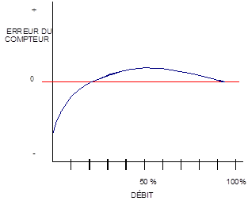
Sections 130, 254 and 291 of the Regulations and in particular section 249, require that a register installed on a volumetric liquid meter be returned to zero before a delivery starts. Section 291 specifies that this is to also occur after the system is drained and has been reprimed.
Contrary to weighing devices, there is no limit of error regarding the accuracy of the return to zero mechanism. Consequently, the mechanism (manual or automatic) shall return the register exactly to zero. This requirement concerns the return to zero mechanism only, and does not include the advance of registering elements under the action of liquid when the pump is turned on.

Section 292 and 293 discusses flow transmitters used for electronic data processing. The flow transmitters in wide spread use these days are required to be dual channel pulser units. Prior to the requirement for dual channel pulser units, a variety of mechanisms were incorporated to accomplish the data processing including reed switches and single channel pulser units.

Section 294
Section 294 requires the registers of bulk delivery vehicles to be equipped with an interlocked ticket printer. The delivery is not normally viewed by the purchaser. When a meter, as described above, is used in trade, a meter-printed ticket indicating the quantity delivered must be given to the purchaser at the time of delivery.
With the older style of mechanical ticket printing register, the register was designed so that it “pinned” or locked the ticket in place and couldn’t be removed without damage until the delivery was completed. With electronic registers a ticket is printed automatically at the end of the delivery or on a time out feature of the electronics.

Section 295
Section 295 advises that the standard condition acceptable in Canada for the resale of petroleum products is temperature corrected to 15°C
Any liquid measuring device equipped with an automatic temperature compensator, or other compensator, and a printer, must issue tickets bearing the statement that the volume has been corrected to standard conditions. This statement must be in close proximity to the volume registration. With regard to temperature compensation, the following are acceptable examples of words and/or abbreviations (see bulletin V29 section 5.5):

"Volume corrected to 15°C" "Vol. corrected to 15°C"
"Corrected litres at 15°C" "Vol. correction to 15°C"

NOTE: The word "corrected” may be replaced by "adjusted". The word "at" is interchangeable with "@". The symbol for degrees is interchangeable with "degrees".
The message should read the words "correction", "corrected", or "adjusted" to indicate that volume has in fact been adjusted as if it had been measured at 15 °C.

Retail fuel dispensers equipped with a money acceptor and card lock fuel dispensers (including high-speed gasoline and diesel refuellers) are exempt from needing to print this statement on the receipt.

